Part - 2 chapter - 10
Aplia Homework: Bringing in the Supply Side: Unemployment and Inflation?

1. Aggregate supply definitions
The short-run aggregate supply curve shows:

Changes in output in an economy as the price level changes, holding all other determinants of real GDP constant
The relationship between the price level and aggregate expenditure
How firms respond to changes in interest rates
What happens to output in an economy when the government spends more money?

Which of the following are assumed to remain unchanged along a given short-run aggregate supply curve? Check all that apply.

The position of the aggregate demand curve
Input prices
Institutions, such as patent laws and tax systems, that make up the "rules of the game"
Real GDP

The term full-employment unemployment rate refers to:

The unemployment rate that occurs when an economy's real GDP is equal to its potential output
The unemployment rate that would occur if there were no frictional unemployment
The unemployment that arises due to purely seasonal factors, such as unemployed lifeguards in the winter
The minimum possible unemployment rate for an economy

Complete the following table by matching each definition to the appropriate economic time frame.
Definition | Short Run | Long Run
A period of time in which some input prices and wages are fixed | ____ | ____
A period of time long enough for all input prices and wages to be renegotiated | ____ | ____

2. Determinants of aggregate supply
The following graph shows an aggregate supply curve (AS) for a hypothetical economy. Suppose the aggregate supply curve shifts to the right from AS1 to AS2, causing the quantity of output supplied at any price level to rise. In this case, the quantity of output supplied at the price level of 125 rises from $250 billion to $300 billion.
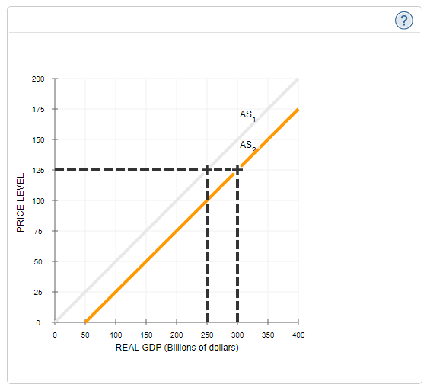

The following table lists several determinants of the aggregate supply.
Use the drop down lists to indicate the changes in the determinants that could have caused the rightward shift of the aggregate supply curve.
Determinant | Change Needed to Increase ASAS
Supply of Labor and Capital | ________
Input Prices | ________
Nominal Wage Rate | ________
Technology | ________

3. The short-run and long-run supply response to a change in the price level
The following graph represents the aggregate supply (AS) curve based on an expected price level of 150. The economy's potential GDP level is $9 trillion.
Major unions across the country have recently negotiated three-year wage contracts with employers. The wage contracts are based on an expected price level of 150, but the actual price level turns out to be 100.
Show the short-run effect of the unexpectedly low price level by dragging the curve or moving the point to the appropriate position.
Note: To move the curve, select and drag any part of the curve except the point. To move the point, select and drag the point along the curve. If you want to move both, first move the curve, and then move the point. The curve and point will snap into position, so if you try to move one of them and it snaps back to its original position, just try again and drag it a little farther.

Interpret the change you drew on the previous graph by filling in the blanks in the following paragraph:
The lower-than-expected price level causes firms to earn _______ profit than they expected on each unit of output they produce, and, therefore, they ________ their production level. At the same time, the real value of wages and other resource prices is _______ than workers and firms expected when they signed long-term contracts. As a result, the economy as a whole produces at a level _______ its potential GDP, and unemployment is _______ than its natural rate.
Now, suppose prices remain lower than expected. As a result, in the next round of labor negotiations, unions accept lower wages for their members. The following graph shows the potential GDP for this economy as well as the same initial aggregate supply curve as in the first graph.
Show the long-run effect of the labor negotiations by dragging the either the aggregate supply (AS) curve or the potential GDP (PGDP) curve to the appropriate position.
Note: Select and drag one or both of the curves to the desired position. Curves will snap into position, so if you try to move a curve and it snaps back to its original position, just drag it a little farther.

4. Equilibrium
The following table shows the real output demanded and supplied at various price levels in a hypothetical economy.
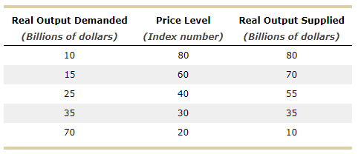
On the following graph, use the blue points (circle symbol) to plot the aggregate demand (Initial AD) curve for the economy. Then use the orange points (square symbol) to plot the aggregate supply (AS) curve for the economy.
Note: Line segments will automatically connect the points.

The equilibrium price level is _______, and the equilibrium level of real output is _______.

The change in government spending _________ the equilibrium level of real output by _________. The price level increase _________ the multiplier effect.

5. Macroeconomic equilibrium and the multiplier effect
The following graph shows a hypothetical economy in short-run equilibrium at an output level of $400 billion and a price level of 100. Suppose that potential GDP in this economy is $600 billion.
Use the grey line (star symbol) to plot the long-run aggregate supply (LRAS) curve on the graph.

Based on the graph, this economy is experiencing ________. The size of the of the gap is _______ billion.

Shift the aggregate demand (AD) curve to illustrate how potential output in this economy can be restored.
Note: Select and drag one or both of the curves to the desired position. Curves will snap into position, so if you try to move a curve and it snaps back to its original position, just drag it a little farther.
To eliminate the GDP gap in this economy, the aggregate demand curve must shift to the _______by ________ billion at each price level.

Suppose that each $100 increase in disposable income causes consumption spending in the economy to rise by $60. The economy's marginal propensity to consume (MPC) is ________, which means that the oversimplified multiplier for this economy is ________ and the shift in the aggregate demand curve required to restore the potential GDP level would occur if investment spending ________ by ________.

6. The sources of inflation and stagflation
During World War I and World War II, the U.S. government spent large sums of money on the war effort. Following both of these periods, the United States experienced double-digit inflation.
The following diagram shows the aggregate demand (AD) and aggregate supply (AS) curves for the United States before the inflationary period.
Shift one of the curves to illustrate the primary cause of the inflation described in the preceding paragraph.
Note: Select one of the curves and drag it to the desired position. The curve will snap into position, so if you try to move the curve and it snaps back to its original position, just drag it a little farther.

True or False: Economists would refer to the situation depicted in the diagram as “stagflation.”
True
False

7. Economic fluctuations
The following graph shows the short-run aggregate supply curve (AS), the aggregate demand curve (AD), and a vertical line at potential GDP representing the long-run aggregate supply curve for a hypothetical economy. Initially, the expected price level is equal to the actual price level, and the economy is in long-run equilibrium at its potential GDP, $100 billion.
Suppose war in the world's main oil-producing region sharply reduces the world oil supply, causing oil prices to rise and increasing the costs of producing goods and services in this economy.
Use the graph that follows to help you answer the questions about the short-run and long-run effects of the increase in production costs. (Note: You will not be graded on any adjustments made to the graph.)
Hint: For simplicity, ignore any possible impact of the higher oil prices on potential GDP.
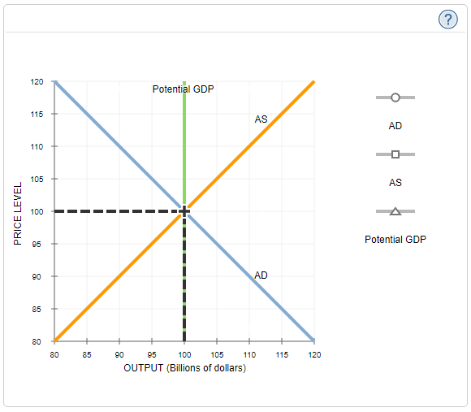

The short-run economic outcome resulting from the increase in production costs is known as _________.

Now suppose that the government immediately pursues an accommodative policy by increasing government purchases in response to the short-run economic impact of the higher oil prices.
In the long run, when the government pursues accommodative policy, the output in the economy will be ________ billion and the price level will be _______.

8. Applying the AD-AS model to a growing economy
Consider a fictional economy of Shana. The following graphs show aggregate supply and aggregate demand curves for two years—1996 and 2007—in which the economy of Shana experienced growth.
Refer to the following graphs to answer the questions that follow.
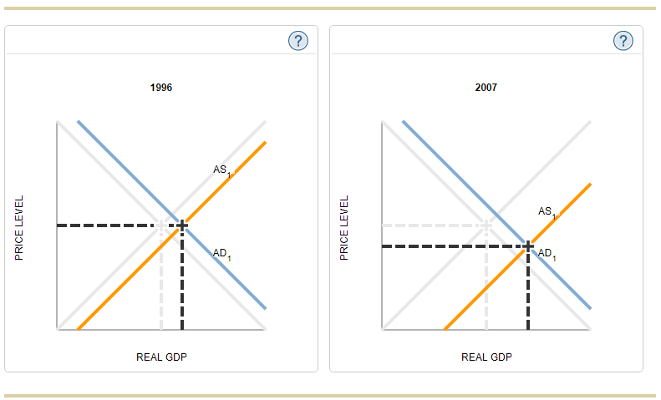
Based on these graphs, fluctuations in the growth rate of the economy of Shana come primarily from variations in the rate at which aggregate supply increases.

True or False: Based on the source of fluctuations, GDP in Shana will grow more quickly when inflation is relatively low.
True
False

